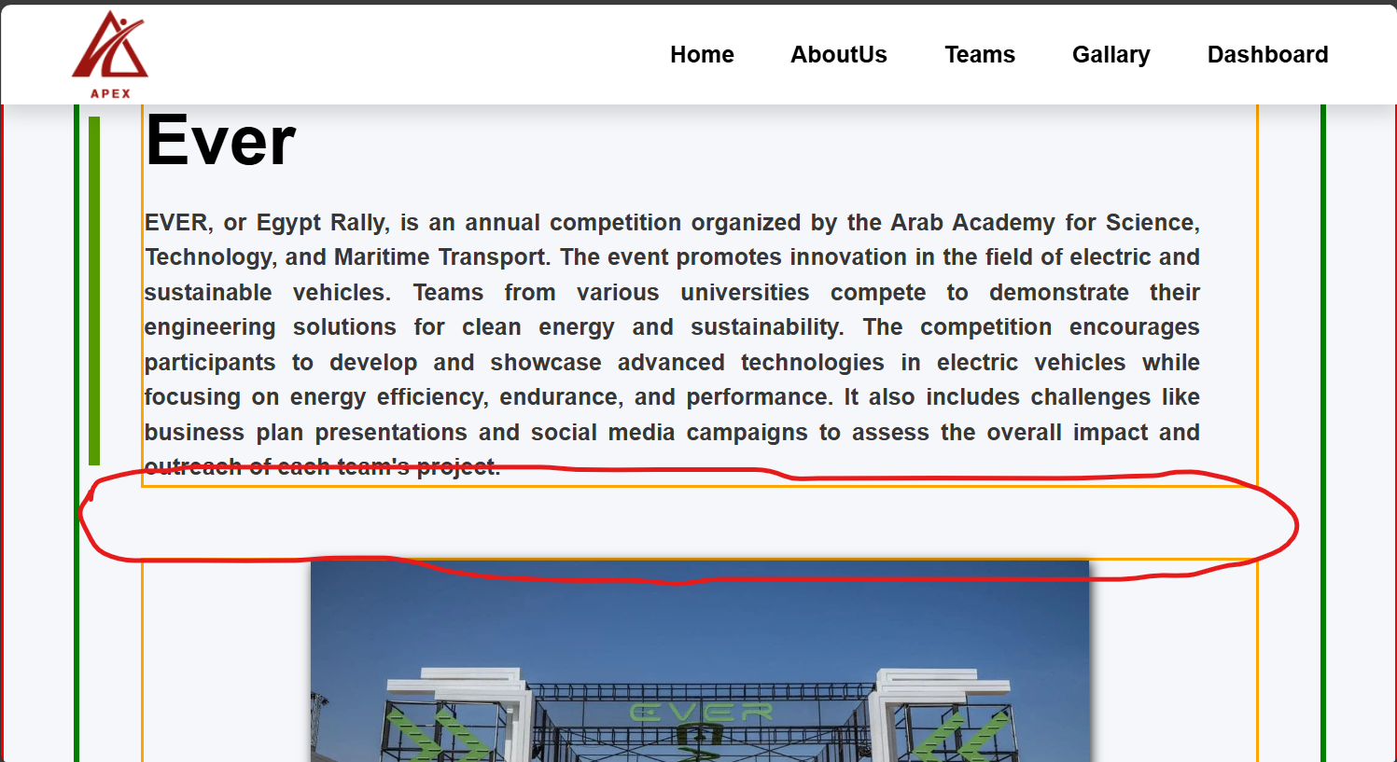Margin top between items in responsive design:60px

Responsive design

* 1200px: textContainer Or something like that 90% , img:70.
* 1000px: img:80%.
* 800px: textContainer or something like that 100% , img:90%.
* 600px:img: 100%.